Introduction
I’m developing a survivor-like (aka term twin stick shooter or Vampire Survivors clone) to sell on Steam for $5-$10. I have little artistic or musical talent, so I’m looking for a musician/audio designer and a 2D artist to help out. If you’re reading this, it means I’m hoping you’ll be one of those two people, and I want to give you a detailed overview of the project!
The estimated length of the project is 3 months, but I am admittedly terrible at estimating the time needed for large projects, so who knows?

Table of Contents
Contents
Introduction 1
Table of Contents 1
Payment 2
Definition of Profits 2
Legal Stuff and Profit Distribution Logistics 2
Genre details 3
Details Specific to this Game 4
What I Expect – Audio 4
Vital Audio 4
More Audio 5
What I Expect – Art 5
Weapons 6
Enemies 6
Playable Characters 6
Maps 7
UI 7
Closing Thoughts 7
About me 8

Payment
Since I have no money, I cannot pay you a wage/salary. What I can do is offer a percentage of the profits. If that’s a dealbreaker for you, I totally understand, as this is expected to be a large time investment.
I’m expecting 3 people to work on this project: myself, an audio person, and an art person. I’m offering the following profit distribution:
- Myself: 50%
- Audio person: 25%
- Art person: 25%

Definition of Profits
It costs $100 to publish a game on Steam, which I will pay out of pocket. Afterwards, a modest percentage of the sales revenue goes to Steam, and the rest goes to me. So profit will be any of the money given to me by Steam after they take their cut and apply any of their taxes. HOWEVER, the first $100 will go only to me to offset the publishing cost.
When the game reaches a sales revenue of $1000, Steam will refund the publishing cost. This refund will be distributed as normal profit.

Legal Stuff and Profit Distribution Logistics
Because (a) I do not own a corporation and (b) I am not a lawyer, you’re collaborating on this project at your own financial/legal risk. It is my understanding that we are to consider revenue from this project as “self-employed” revenue for taxes, though of course it varies based on where you live.
The easiest way to distribute profits for me would be to just Venmo the art person/audio person their share at a standard interval- I believe Steam pays monthly so a monthly interval would make sense. If you want me to check outside of the interval to see if there’s any money waiting for you that’s fine, I just don’t want to check every day.
If you’re not comfortable trusting a stranger with your money, I totally understand that. We can try and work something else out, maybe a legal contract or maybe even Steam can handle it for us. I haven’t done the research to know all the options but I’m sure we can find a method that everyone’s happy with.

Genre details
If you’re familiar with survivor-likes you can just skip this whole section. I just figured some readers may not be avid gamers and may be unfamiliar with the genre.
Survivor-like is a fairly new subgenre of Action Roguelike with a rather specific set of gameplay elements. The name comes from Vampire Survivors. I’m not sure if Vampire Survivors was the first in the subgenre, but it’s certainly the one everyone knows about. My favorites from the subgenre are:
- Spellbook Demonslayers
- Brotato
- Soulstone Survivors
In brief, the parent genre Roguelike is characterized by:
- The game is fairly short and very random and is meant to be played all the way through multiple times.
- There are no checkpoints- if you lose you must start a new game.
- The core game is often wrapped in another content layer that offers some persistent elements, such as achievements or unlocks. Also known as meta-progression.
  - A full playthrough of the core game is usually called a “run” to distinguish from a full playthrough of the wrapper.
Nearly all survivor-likes have the following elements:
- Singleplayer
- Action
- Top-down camera with player character locked in the center of the screen
- Runs take place in an arena
- Run lengths of 20-40 minutes
- The primary goal of the run is to survive until some condition is met (time, kills, etc.)
- Hordes of enemies spawn continuously and move towards you.
- Enemies get stronger over time.
- The typical way to survive is to kill enemies as fast as they spawn.
- Enemies drop experience shards on death, scaling with their strength.
- Collecting experience shards lets you level up (experience required increases with level). This is the primary way to get stronger.
  - When levelling up, you are presented with a choice of ~3 upgrades randomly drawn from a pool of dozens to hundreds of weapons and passive abilities.
- You start with 1-2 weapons, which trigger automatically on a timer. Through levelling up you can acquire a few more weapons, typically about 6 total.
- Weapons can be upgraded individually.

Details Specific to this Game
This is still very much a work in progress, but I do have some ideas about how to give this game its own identity:
- The meta progression will be primarily unlock based
  - Completing objectives during your runs will unlock new weapons, passives, maps, etc.
  - Each character will have their own unlocks for completing objectives while playing as them.
    - Similar to the marks in Binding of Isaac
- The game will be very difficult
  - A lot of Survivor-likes are easy enough to beat within 3 or so tries after installing the game. That is boring imho.
  - Dying is intended to be fun.
  - Getting better at the game will not feel pointless.
  - 100%ing the meta-progression will not trivialize the challenge.
- Different playable characters will have interesting and unique abilities.
- Rather dramatic theme/feel
  - Flashy
  - Bloody
  - Sexy
  - Similar theme to Bayonetta and Devil May Cry
- Evolution mechanic
  - Many Survivor-likes (including Vampire Survivors) feature weapon evolutions: you reach a certain condition, and you can upgrade your weapon into a new form that is not only better, but behaves rather differently too!
  - This game will have an evolution mechanic, but hopefully a bit more of a sophisticated one, like BallxPit’s “combination” mechanic.

What I Expect – Audio

Vital Audio
This is the bare minimum I’m happy releasing the game with. How much more you do is really up to you and I guess depends on how much work you can get done by the time I finish coding. If you need another few weeks or something then that’s fine of course.
- At least one main combat theme
- SFX for weapons
  - I haven’t thoroughly designed any weapons yet, so you’d probably need to hold off on that.
- SFX for menu actions
  - Not every menu action needs a sound, but maybe changing from one menu to another, saving the game, and starting a new run.
- SFX for taking damage, dying, and levelling up
  - You could probably start the main combat theme right now.
    - My favorite music genre is metal, and while it’s not everyone’s cup of tea, I think it would fit the theme of this game well.
    - Vocals in video games is unusual in general but I’m not opposed to it. Female vocals preferred.
    - If you would prefer a different music genre then I’ll consider it!

More Audio
- A menu theme would be nice. Something that would play while doing menu things including:
  - Browsing meta-progression menu (if there is one)
  - Character select
  - Stage select
- There will probably be 3-5 different maps (they won’t vary all that much) so a combat theme for each would be excellent. Alternatively, just 1-2 alternative combat themes that are randomly substituted in to keep things fresh.
- Possibly an additional theme for boss fights.
I don’t need you to integrate the audio into the game, just .wav files is all I need!

What I Expect – Art
Currently I’m expecting the graphics to be generally 16-bit (or pseudo hi-res) style pixel art, though a mix of pixel art and hi res splash art such as in Shantae and the Pirate’s Curse would be cool.
Games with this style of art include:
- 20 Minutes Till Dawn
- Hammerwatch
- Various Shantae games
- Terraria
- Loop Hero
- Slice & Dice
- Songs of Conquest
- Rogue Legacy
- Spellbook Demonslayers
- Wings of Vi
- Legend of Keepers
For all of the sprites, I’ll send you details about them when they’re ready.

Weapons
Every weapon will need to have its own sprite, whether a sigil on the floor, a bullet, or a slash. Some of them should preferably be animated, though I don’t expect more than like 5 frames. (I mean even smash ultimate only has like 5 frames for its attack animations.)

Enemies
Enemies each need their own sprites. I’m not sure how many enemy types I’ll have, maybe like 5-30, with at least 1-10 bosses. It depends on how much time you need to draw them and how much time it takes me to design them. Enemies can be pretty simplistic, as long as it matches the rest of the game’s artstyle.

Playable Characters
Playable characters (5-10?) need their own sprites. After some deliberation, I have decided I want them to all be women, and I want like half of them to be half naked. I’ll send you more details later but here’s some specifics on what’s “too sexy” for this SFWish game:
Preference for stylish-sexy, not fanservice-sexy. Think something Bayonetta would wear. Or like Helltaker’s Judgement.
- No cameltoe or nipple imprints
- Avoid impossibly disproportionate sex appeal like Chun Li or Cordelia from Dead Estate
- Impractical armor ok
  - Including boob shaped breastplate
- Short skirts & upskirt shots ok
- Fighting in heels fine
Outfit examples:
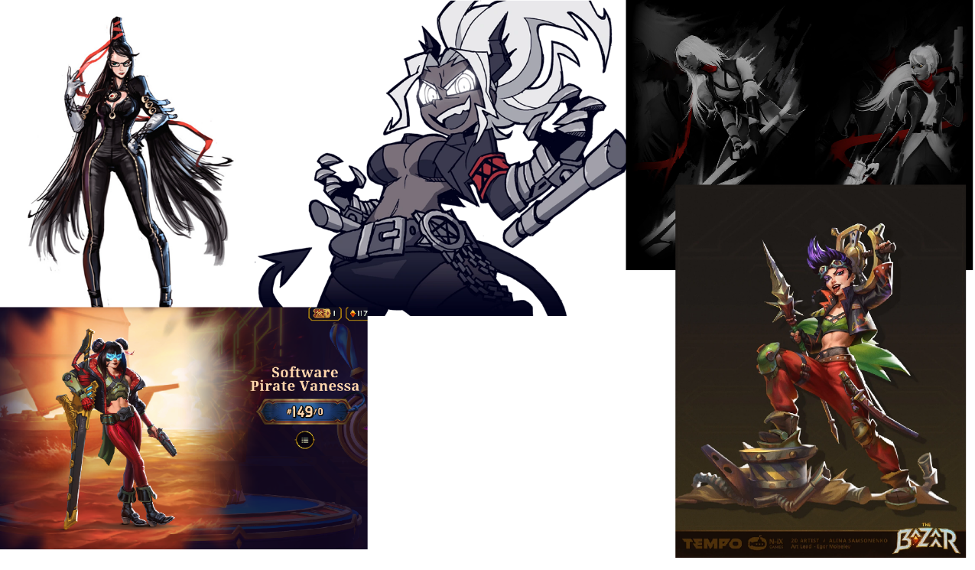

Maps
Each map (3-5?) will need artwork. I’m not totally sure what the best way to handle that- one 30000x30000 picture? Something created directly in the editor? I’ll have to look into that. But I do expect there will be a lot of tiling, and the maps really don’t need to look that different.

UI
Menus, buttons, and UI would be appreciated. That sort of stuff is usually done in the editor but you could give me something to start with (like a background, border, and font for a textbox) and I can try to implement it.
You don’t have to integrate anything into the game, just .png files are fine!

Closing Thoughts
If you have any questions, don’t hesitate to ask. And if you have any suggestions for theme, weapons, playable characters, or whatever else, I’d be glad to hear it. I accept that you’re not just more skilled than me in your area, but more knowledgeable too, and I don’t want to force you to do something if you think there’s a better way.
Oh, and if you need inspiration/more detail about the genre you could probably convince me to buy you a Survivor-like game. Especially Spellbook Demonslayers.

About me
Hello, my name is NauPhy. I’m 24 and hoping to launch a career in game development. I applied to a bunch of jobs and no one wanted me, so I decided to just make a couple of games myself and see how it goes. If they’re successful, I’ve got my dream job, if not, I’ll have to do something more boring.
My first game was Incremental Dungeon, which had pretty encouraging reception on Steam. It’s been 23 days since launch, and I’ve made about $200 profit. Given the 600 hours I spent on it that’s nowhere near a living wage, but it is free (with a $5 supporter pack) so that’s about what I expected. This next game will be the real test.

